Westhaven Elementary School
Parent Engagement Policy 2019 - 2020
Learning for students takes place at school, at home, and throughout the community. At Westhaven Elementary School, we believe that the school has a responsibility to provide high-quality curriculum and instruction in a supportive and effective learning environment that enables the children served under Title I to meet and exceed the State’s student performance standards. The strengths and contributions of families and communities are highly valued. Parent involvement is key to the success of students.
Parents and the community are integrated into the school program through their involvement in the governance structure, volunteering, PTA programs, and voice in shared decision-making. There is a shared vision and high expectations for student learning and achievement. Working together provides a clearer sense of direction and unity of purpose, as well as providing opportunities to exchange ideas and viewpoints.
We have involved parents in the planning, review, and improvement of the comprehensive school wide program plan by involving parents in the PTA Executive Board. A Title I Parent Involvement Committee will meet bi-annually to discuss, review, and implement changes as needed to the Parent Involvement Policy and Plan.
The Parent Involvement Policy and the Parent Involvement Plan will be available on the school’s website and a parent informational session will be held in the fall to review the plan and discuss concerns with parents. A copy of the School Improvement Plan is available in the office for review by parents.
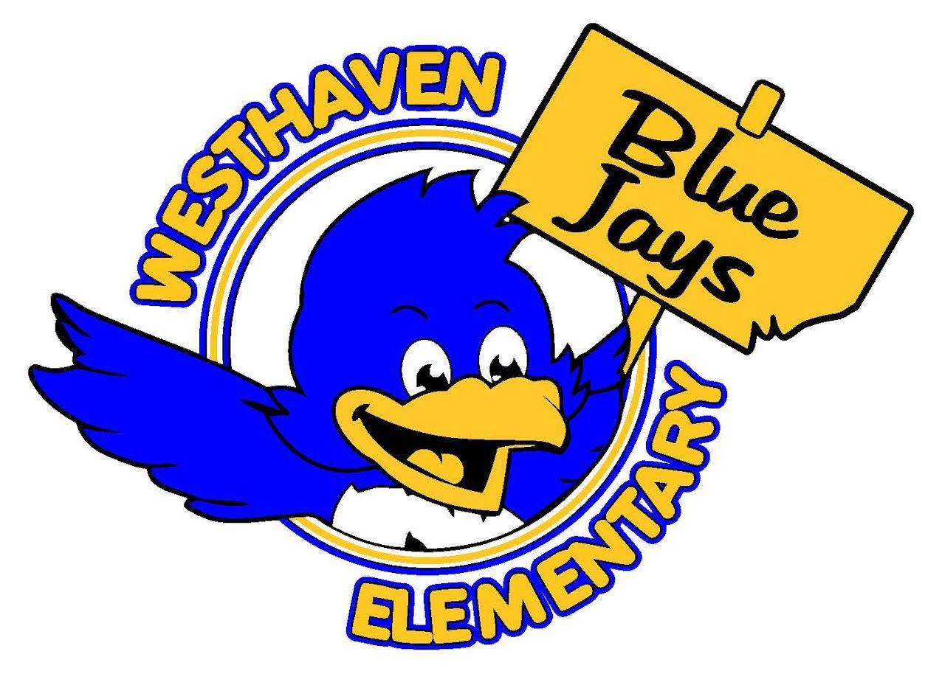

The goal of Parent Involvement at Westhaven Elementary School is to include parents as active participants in their children’s educational experience and academic success. Parent Involvement initiatives are carefully planned to communicate with parents on a consistent, regular basis to involve parents in student instruction and achievement, and to involve parents in school wide governance and decision making.
● Parent-Child Enrichment Opportunities, Parent Trainings, and Parent Meetings:
Parent Involvement Opportunities are scheduled throughout the school year using a
flexible schedule with funds provided under Title I.

● Annual Meeting: An annual meeting will be held in September, to which all
parents shall be invited and encouraged to attend. The purpose of the meeting is to
inform parents of their school’s and district’s participation under Title I and to explain
Title I requirements, and the right to be involved. Additionally, the results of the
annual school review are discussed, including the school’s overall performance on
state mandated assessments according to VDOE. The following areas to be
addressed at the annual meeting include:
1. National Education Goals
2. State’s content standards and student performance standards
3. School improvement
4. Components of a school wide plan
5. State and local assessments
6. Requirements of Title I, Part A
7. Ways parents can monitor their children’s progress and work with educators to
improve the performance of their children.

8. Ways parents can participate in decisions relating to the education of their children.

● Title I Parent Involvement Committee: This committee consists of the school
principal, teachers, parents, and community members to represent the diverse
population of students within the school. This committee meets quarterly and
periodically reviews and implements changes as needed to the school Parent
Involvement Policy and Plan. This council is involved in the joint development and
evaluation of the school-parent compact that outlines how the school and the
parents will be responsible for supporting student learning. This committee will also
work with parents to evaluate the effectiveness of the parent involvement initiatives
as a measure of performance evaluations of the school.

● Coordinate and Integrate Parent Involvement with other programs: We will
coordinate and integrate our parent involvement efforts with Family Systems,as well
as community-based organizations and businesses.

● Ongoing communication between school and parents: We will address the
importance of parent-teacher communication via parent conferences, frequent
reports on children’s progress, and by providing access to staff and opportunities to
volunteer and participate in school activities. The Title I Parent Involvement Policy
and Plan will be distributed to all parents at the beginning of the school year for
their review and input. Additional opportunities for Parent Involvement and Parent-
Teacher Communication are listed below.

Parent Involvement Plan and Strategies to Support the
Title I Parent Involvement Policy

1. Open House: Each year, the staff of Westhaven Elementary School
welcomes new and returning parents to the school for an open house. The event is
traditionally held prior to the beginning of school and is a valuable opportunity for
parents to tour the school, meet the teachers, and ask questions about the
expectations for the school year. Information is also given regarding school-related
programs and volunteer opportunities for parents.

2. SOL Family/Benchmark Nights: Academic nights, focusing on a variety of topics, are
held throughout the year. These events provide parents with valuable information
regarding the school’s curriculum and how they can support student achievement at
home. Large and small group opportunities are provided to encourage parents to
explore the curriculum with their children and to ask questions. Academic nights
and other parent meetings will be held at various times and locations. The principal
and administration will provide timely responses to parent suggestions provided at
these meetings.

3. PTA Executive Board: Our PTA Executive Board consists of members who are
representatives of our school. They provide advice, recommendations, and assistance.
These representatives attend meetings and share ideas for school improvement,
provide support for teachers and administrators, and are a part of the decision-
making process.

4. School Leadership Team: Our school leadership team consists of representatives
from all grade levels, support personnel, and administration. Portions of our
leadership team are parents. This committee serves as a decision-making team for
the school and works to plan for curriculum implementation and evaluation, to
evaluate student achievement and performance, and to plan for school
improvement.

5. Parent Meetings: The principal shares pertinent information with parents regarding
upcoming events and decisions at meetings. Parents are notified of meetings by
social media, phone, and newsletters. The meetings provide parents the opportunity
to discuss questions and concerns with the principal. The principal and
administration will provide timely responses to parent suggestions provided at these
meetings. The principal is also available for meetings concerning private issues.

6. Parent Conferences: Parent conferences are scheduled on a regular basis before,
during, and after school hours. Teachers keep a record of parent conferences held
throughout the year and encourage all parents to attend. To ensure that all parents
are included in parent conferences, individual student assessment results and
interpretation of these results, as well as a description and explanation of the
school’s curriculum are provided at these parent-teacher conferences.

7. Parent-School Compacts: Parents are asked to set goals for themselves in
participating in their child’s education. These goals are listed along with the teacher
and administrative/instruction team in a compact for all students.

8. Counselor: The counselor is available to assist parents with specific concerns.
Resources are also available to assist parents and students with specific concerns
including difficulties with school, problems with peers, anger, and grief. Parenting
resources such as books and periodicals are also available.

9. Volunteer Program: Parents may volunteer at our school in a variety of ways. Please
contact the principal for more information.

10. Staff Development: Westhaven staff will work together to educate teachers
and other staff, in the value and utility of contributions of parents, and how to reach
out to, communicate with, and work with parents as equal partners, implement and
coordinate parent programs, and build ties between home and school.
Communication between School and Parents on an Ongoing Basis
1. Calendar: A monthly calendar is sent to parents. This calendar contains information
for parents regarding upcoming events, student success, and tips for helping students achieve.

2. Parent Phone Calling System: Important information for parents is communicated on
a regular basis via a mass calling system. This system allows the school
administration to contact parents via telephone regarding upcoming events and
important announcements.

3. Agendas: All students in grades 2-6 receive a daily agenda which is to be signed
daily by teachers and each night by parents. These agendas provide an opportunity
for parents and teachers to communicate on a daily basis regarding expectations for
students, student progress, and concerns.

4. School Website: Our school website provides pertinent information for parents and
community members. Parent links include information regarding student
achievement, school improvement, the school lunch menu, and upcoming events.

https://schoolquality.virginia.gov/schools/westhaven-elementary

5. Power School is the district student information website that provides parents with
information regarding their child’s attendance and a variety of other factors
concerning academic performance.

Parent Rights
● Parents have the right to receive information on how they can support their
children’s learning at home.

● Parents have the right to have their children’s performance and report cards clearly
explained during parent-teacher conferences and in other school meetings.

● Parents have the right to express their opinions, register their concerns, and have them
addressed in a timely manner by the appropriate school personnel.

● Parents have the right to be provided with opportunities for their involvement in the school
community through parent-teacher conference days and student-parent days.

● Parents have the right to be given reasonable access to the school building.
Parents have the right to observe their child in class.

● Parents have the right to know that the school will maintain up-to-date emergency
contact and health information.

● Parents have the right to receive information about the school’s policies and
procedures and have access to their children’s records.
Parent Responsibilities
● Parents will support efforts to raise student achievement and will participate in
ongoing two-way communication with the school to ensure early identification of
student needs.

● After teacher notification, parents will follow up with the school or teacher, if such
follow up is needed, and attend scheduled meetings, make phone calls, email or
notes to maintain contact.

● Parents will participate in discussions and decisions relating to the education of
their children with appropriate school personnel.

● Parents will learn about opportunities for parental involvement at school and at the
district level and get involved, if at all possible.

● Parents will know and follow school procedures for parent access to the school
building.

● Parents are to encourage their children to resolve conflicts in a respectful and
positive manner. Parents will encourage students to report problems to their
teachers and administration.

● Parents are required to provide the school with current a) family address &
telephone numbers; b) accurate emergency contacts and c) health information.

● Parents will be familiar with the school calendar, school safety plan, discipline code, and
will discuss these topics with their children.
Student Responsibilities

● Students will study for examinations, do homework and other assignments.

● Students will listen to and talk with their parents and teachers about their
performance and progress.

● Students will talk to their families about what they are learning and doing in school.

● Students will know and follow school procedures for access to the school building.

● Students will strive to resolve conflicts in a positive and respectful manner and seek
help from teachers and the administration when needed.

● Students will transmit any necessary correspondence to and from school personnel
and parents.

● Students will be familiar with the school calendar, school safety plan, discipline
code, and will discuss these topics with their parents. Students will follow school
discipline code on the bus, at school and at extra-curricular events.

School Responsibilities

● The school will provide information and tools to parents so they can help their
children to achieve academic and social progress.

● The school will provide opportunities for parents to discuss student achievement as
reported on report cards and/or during parent-teacher conferences.

● The school will be responsive to parents’ questions and concerns in a timely
manner. The school will provide information to parents on the complaint processes
available to them. Parents will receive a welcoming environment for all concerns.

● The school will offer specific opportunities for parent involvement, make them
readily available and provide a welcoming environment for all parents.

● The school will communicate school procedures and policies for parent access to
the school building and to their children’s records.

● The school will maintain up-to-date emergency contact and health information.

● The school will provide to parents a clear description and explanation of the school
calendar, school safety plan, the discipline code and the parent-school
communication plan.

Westhaven Elementary School
Parental Engagement Policy Council
Patrick O’Neal, Principal
Patrizia Grigsby, Assistant Principal
Mellissa Asencio, (PTA President)
Mellisa (Missy) Paitsel, (PTA Vice-President)
Darnisha Vincent, (PTA Secretary)
Kelly Abad, Parent (PTA Treasurer)
Shai Haynes, Parent Engagement Liaison
Kiera Hightower, Parent

